**Lesson 1: Integers and Number Lines**

**Key Vocabulary:**

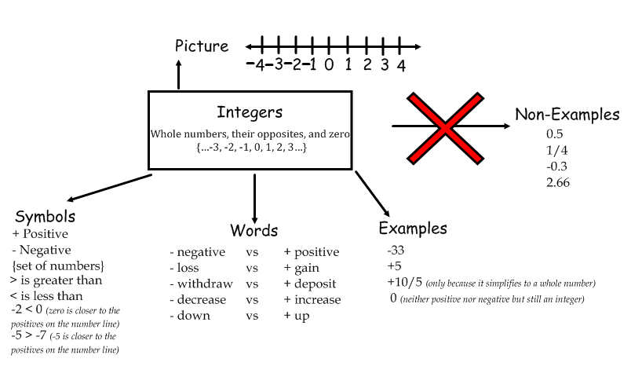

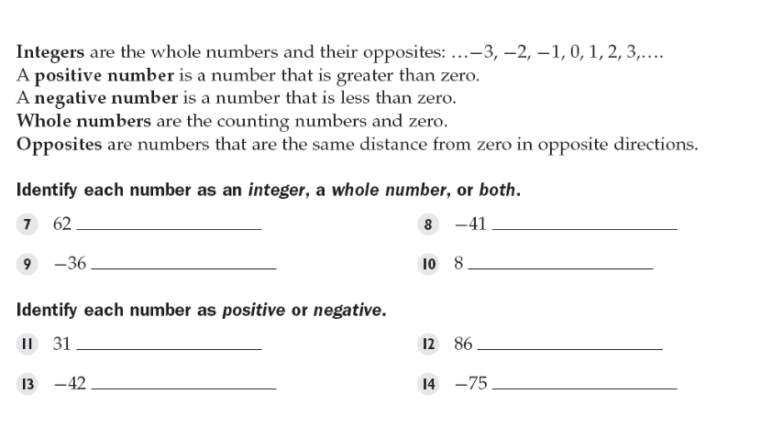

both integer

integer both

positive positive

negative negative

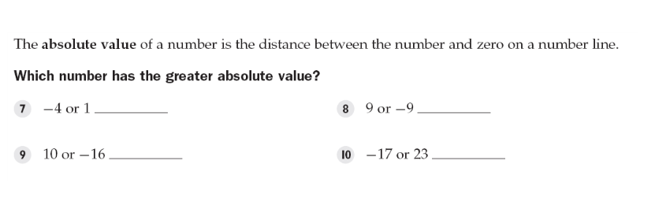

-4 same

-16 23

. . . . . . . . . .

. . . . . . . . . .

**Guided Notes:**

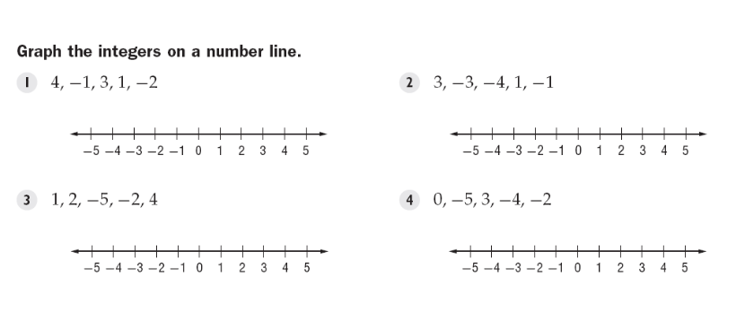

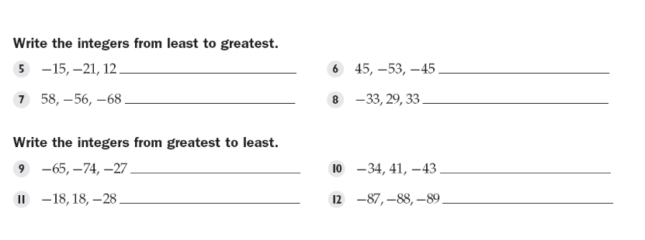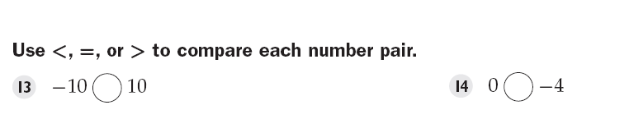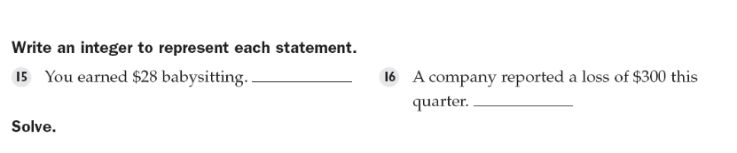

-21, -15, 12 -53, -45, 45

-68, -56, 58 -33, 29, 33

-27, -65, -74 41, -34, -43

18, -18, -28 -87, -88, -89

< >

+28

-300

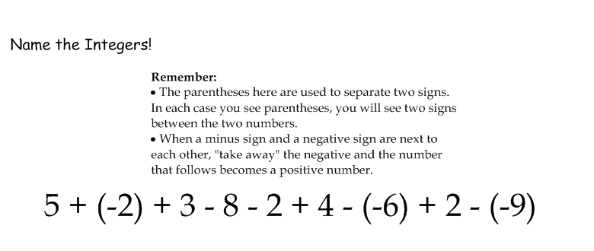

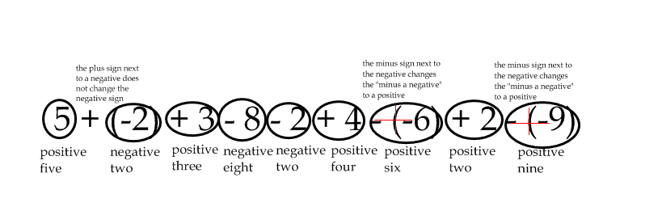

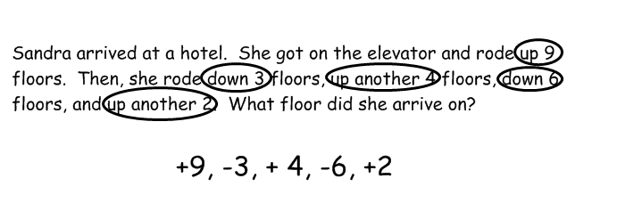

Elijah deposited $32 into his bank account. Then, he withdrew $20 in order to go to dinner with his friends. While he was out at dinner, he purchased a video game from his friend and wrote him a check for $15. Then, he got really anxious because he realized he might have overdrawn his account! Should he be worried? How much money should he deposit the next morning?

**+32, -20, -15 = -3. Needs to deposit $3**

**Structured Practice:**

1. **Batman drove his Batmobile to the right 5 meters, then left 7 meters, then right 15 meters, then left 8 meters.**

**5-7+15-8 = 5**

1. **Superman flew up 15 meters, back down for 8 meters, then back up for 20 meters. He ascended another 20 meters before he dove back down for 9 meters.**

**15 -8+20+20-9 = 36**

1. **Eric spent 10 minutes on his lesson plan before he got lazy and spent 3 minutes surfing Facebook. He then worked for 15 minutes on the plan until he got hungry and spent 30 minutes eating. Finally, he spent 60 minutes working on his lesson plan because he was about to run out of time.**

**10-3+15-30+60 = 52**

1. **Alex passed out 15 pieces of paper. But then he took back 9 of them. He passed back 6 pieces of paper, but then he took 13 pieces of paper back. BONUS: Is this even possible??**

**-15+9-6+13 = 13. Sure.**

1. **Come up with your own problem! Be sure that the numbers can be assigned positive or negative values.**

**Guided Practice**

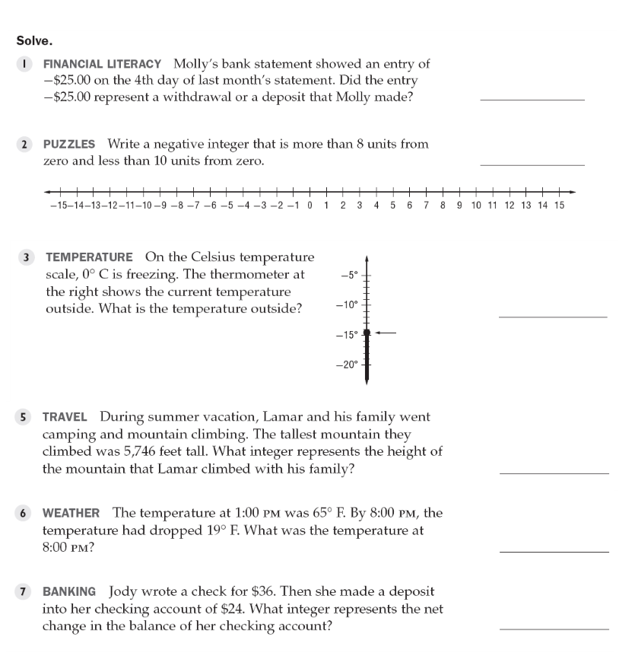

withdrawal

-9

-14 or -15

+5746

46

-36 + 24 = -12

**Independent Practice:**

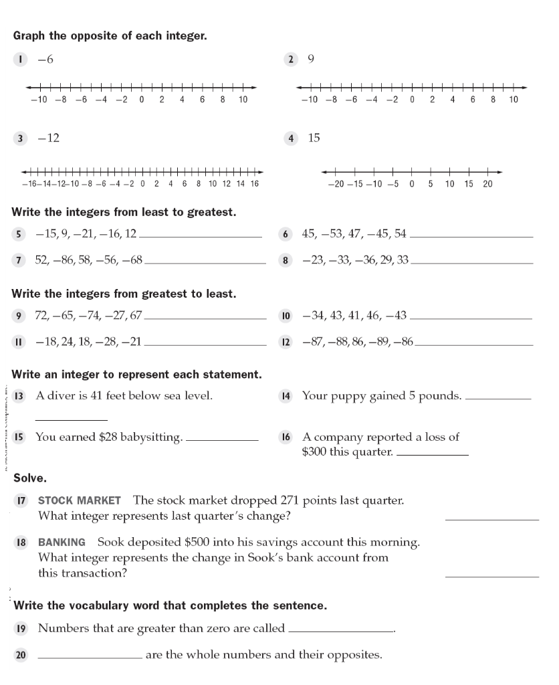

Graph 6 Graph -9

Graph 12 Graph -15

-21, -16, -15, 9, 12 -53, -45, 45, 47, 54

-86, -68, -56, 52, 58 -36, -33, -23, 29, 33

72, 67, -27, -65, -74 46, 43, 41, -34, -43

24, 18, -18, -21, -28 86, -86, -87, -88, -89

-41 +5

+28

-300

-271

+500

positive integers (or counting numbers)

Integers

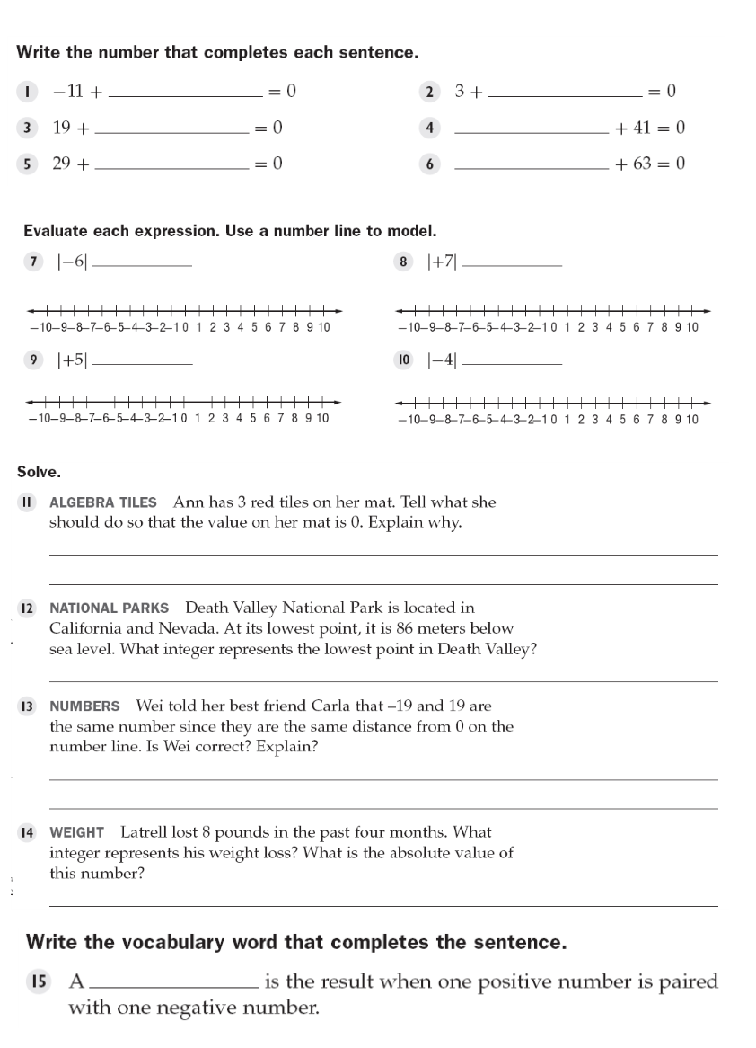

11 (-3)

(-19) -41

(-29) (-63)

6 7

5 4

Take away 3 red tiles

-86

No. They are opposites.

-Negative 8; 8

difference (bad question)